BEM STandards

# BEM STands for

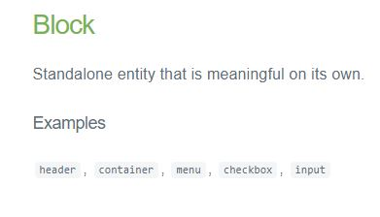

Parent container for a set of elements is named as :- .block

**Like :-**

<div class = ”block”> ….. </div>

**Example :-**

<div class="foundation-finder> …. </div>

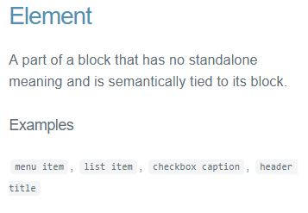

Elements inside a block are named as :- .block__element1

**Like:-**

<div class = ”block”>

<div class = ”block__element1”></div>

<div class = ”block__element2”></div>

</div>

**Example:-**

<div class="foundation-finder>

<div class="foundation-finder__landing></div>

<div class="foundation-finder__one></div>

<div class="foundation-finder__two></div>

</div>

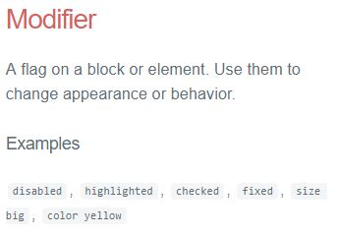

Any modification to an existing common style is given by adding the class as :- .block__element1—modifier (or) . block—modifier

**Like:**

<div class = ”block”>

<div class = ”block__element1--mod”></div>

<div class = ”block__element2--mod”></div>

</div>

**Example:**

<div class="foundation-finder__row”>

<span class="foundation-finder__row--top"></span>

<span class="foundation-finder__row--left"></span>

<span class="foundation-finder__row--right"></span>

<span class="foundation-finder__row--bottom"></span>

</div>

# Why USE BEM

1. To create efficient and organized CSS structure

**Example:**

Wrong way:

HTML:

<div class=”foundation-finder”>

<div class=”grayscale transparent”>

</div>

</div>

SCSS:

.foundation {  
 &-finder {  
 .grayscale {  
 background: $color-grey;  
 opacity: 1;  
 }  
 }  
 .transparent {  
 opacity: 0.5;  
 }  
}

Generates:

// Messy class names  
// Two level of selector classes

.foundation-finder .grayscale {  
 background: $color-grey;  
 opacity: 1;  
}

.foundation .transparent {  
 opacity: 0.5;  
}

Correct way:

HTML:

<div class=”foundation-finder”>

<div class=” foundation-finder__grayscale foundation-finder--transparent”>

</div>

</div>

SCSS:

.foundation-finder {  
 &__grayscale {  
 background: $color-grey;  
 opacity: 1;  
 }

&--transparent {  
 opacity: 0.5;  
 }  
}

Generates: //Neat and efficient with single class name pointing to the element directly

foundation-finder__grayscale {  
 background: $color-grey;  
 opacity: 1;  
}

.foundation-finder--transparent {  
 opacity: 0.5;  
}

1. Reusability



